**Git 1:**

1. Clone:

Clone copies an already existing directory off of GitHub to your pc. The directory can be found in the folder where git bash was used.

Syntax: git clone “URL”

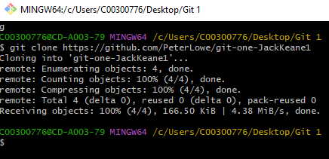

1. Status:

Status gives you information on state of the working area, for example your current branch.

Syntax: git status

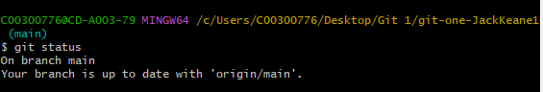

1. Branch:

Branch creates another branch off of the main branch, this allows for work to be done without affecting the main branch. Work can then be merged for the branch to the main

Syntax: git branch “branch name”

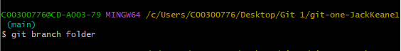

1. Checkout:

Check out is used to swap between branches in the repository.

Syntax: git checkout “branch name”

